**Add a New Customer Overview**

**Add Customer**:

We will add a button "**New Customer**" in "**list-customer**" page.

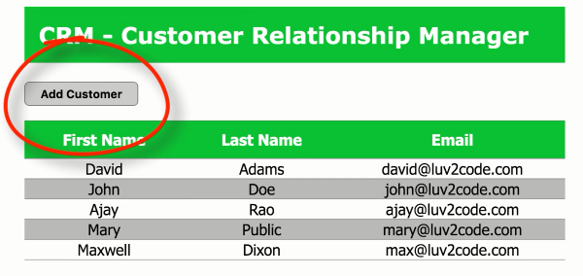

**Field for new customer**:

When we press the "**New Customer**" button it opens a new page "**customer-form**"

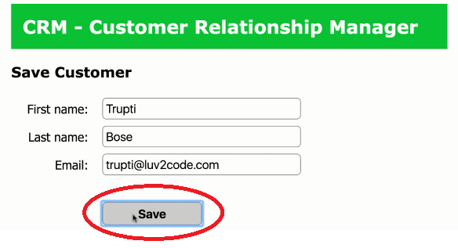

**Save Customer:**

After fill up the field when user press the "**Save**" button, the value will be save in database and display it in the "**list-customer**" page.

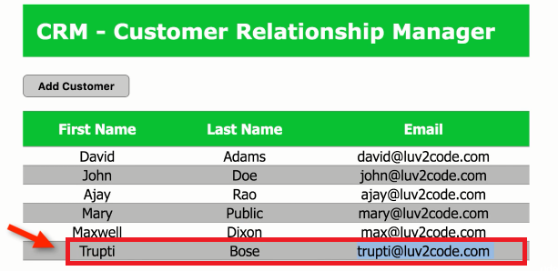

Add a New Customer Overview